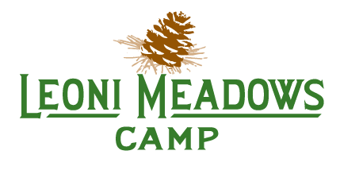
BASE CAMP ACTIVITIES
Cub, Junior, Tween, Teen

Archery
Learn the basics of archery, how to hold the bow, range safety, and tricks to improve shooting. Progress in your skills during the week and receive a progress report and certificate at the end of the week.

BMX/Mtn Biking
Dirt. Jumps. Helmets and pads. Just a few of the basics needed for BMX fun! We have our own BMX track and provide the bikes too!

Canoeing
Enjoy a leisurely paddle around our pond or race the canoe next to you! Our lifeguards will still keep a close eye on you and make sure you're wearing that life vest!

Ceramics
Complete several projects during the week. Choose from bowls, plates, figurines, and much more. Paint with the colors of your choice and watch your project come to completion.

Challenge Course
Overcome your fear of heights. Strengthen your team-building skills. Or just enjoy the thrill of the zipline, giant swing, leap-of-faith, climbing wall, and other low-ropes elements.

Christian Drama
Learn stage presence. Work on memorizing lines and performing together with your classmates.

Digital Photography
Capture your favorite sites on camera and learn how to manipulate or enhance in Photo Shop.

Dirt Dawgs & Mountain Boards
If you enjoyed our Dirt Dawgs last year, you'll love our new Mountain Boards and Mountain Board track. Think over-sized skateboard with big-tread tires.

Go Karts
Fine tune your driving skills on our new state-of-the-art go karts and professionally engineered track. Learn to slide around a corner without spinning out.

Horsemanship
Enjoy a nice trail ride and learn the basics of caring for a horse.

Nature Exploration
Explore the wonderful world around us. Learn about the animals at the petting zoo and enjoy searching for some native creatures too.

RC Rock Crawling
Expand your RC driving skills. Learn to rock hop, climb boulders and over obstacles with a remote control 4 X 4. Test your skill against the best of Leoni.

Rocks & Minerals
Collect your favorite rocks, slice them open to explore the inside and polish gems you find!

Swimming
Splish-splash at the pool!

